Press release June 1st, 2015
ANNOUNCEMENT OF STANISLAV LIBENSKÝ AWARD 2015 - Call for emerging artists!

The Prague Gallery of Czech Glass announces for the seventh time Stanislav Libenský Award.

The prestigious international competitive exhibition of glass for art schools students, the Stanislav Libenský Award, is the only one in the world in which fresh graduates can apply. The competition is open to young artists; graduate Bachelors or Masters, from all over the world, who used glass in their final thesis.

ONLINE APPLICATION, PHOTOS OF THE ARTWORK, CV AND ANNOTATION OF THE ARTWORK MUST BE SUBMITTED NOT LATER THAN TUESDAY 30th OF JUNE 2015 MIDNIGHT (CET)!

The international jury of Stanislav Libenský Award 2015 is composed of distinguished experts in glass scene.
In the first half of July 2015 will the international jury select from all entries candidates, whose works will be exhibited in Prague in autumn 2015.
The final assessment will be based on actual works and will be held on September 17th, 2015. The winner will be officially announced at the gala evening the same day.

The main prize is a three-week stay at the Pilchuck Glass School in the USA. The winner will have the unique opportunity to create at the international scene, meet foreign colleagues and gather valuable experience for her/his future practice.

For detailed information, online application form, competition terms and conditions visit:
www.libenskyaward.com; www.facebook.com/StanislavLibenskyAward

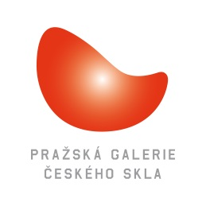
Contact:
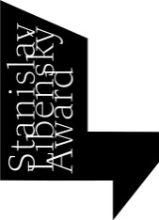
Prazska galerie ceskeho skla, o.p.s.
Bartoskova 26, 140 00 Praha 4 – Nusle
Czech Republic
info@praguegallery.com

